Date: **November 19, 2019, Tuesday**

**TODAY, I AM GRATEFUL FOR:**

1. I got to study for the exam and hands-on for STAT and CMSC 11 (I woke up at 1AM).
2. I felt that my CMSC 11 hands on performance was ok because I did my best.
3. I got explain my STAT 123 teacher about the issue last Friday.
4. I can catch up with my missed activities in STAT 123 soon.
5. I got to have my part in the finals in the PE Arnis class even though I can’t spar.
6. I got to talk with a good friend about her feelings and just being there for her.

**TOMORROW, I LOOK FORWARD TO**

1. Do my best in the Math LE that I missed out last week due to my Dengue condition.
2. Finish my part in the PE finals.
3. Support my friends in the PE Finals.

Date: **November 20, 2019, Wednesday**

**TODAY, I AM GRATEFUL FOR:**

1. I finished my job in the PE finals. I felt proud that I got to make the certificates for the event.
2. My friends did well in the finals. I got to birg them haha. Two of them even got the champion for their division.
3. I felt I did well in my Math LE. I did my best after all.
4. Spend time with my friends.

**TO MORROW, I LOOK FORWARD TO:**

1. Catch up with my class in CMSC 56 & Math 53.
2. Do well with my SAS Class.
3. Get to eat the mango floats Mama made hehe.

Date: **November 21, 2019, Thursday**

**TODAY, I AM GRATEFUL FOR:**

1. After all the pressure in my other subjects, SAS is a “breather” that I can express myself to others without judgement.
2. I was able to catch up little by little in Math 53.
3. Our SAS presentation was a success (in my opinion). I had fun explaining my passion in music.

**TOMORROW, I LOOK FORWARD TO:**

1. Catch up with STAT
2. Catch up with CMSC 11
3. Catch up with Math
4. Attend the last bible sharing with the UP Fiat
5. Get to spend time with my friends ~ have our session.

Date: **November 22, 2019, Friday**

**TODAY, I AM GRATEFUL FOR:**

1. No classes in STAT lec and lab. I had more time with catching with my subjects.
2. I was able to practice and really got better in my coding skills in CMSC 11.
3. I was able to attend the last bible sharing for UP Fiat. There was also free food!
4. I got to spend time with my friends in Pantera Rosa. In our “session”, we got to know about each other and even got to perform live acoustic to the people.

**TOMORROW, I LOOK FORWARD TO:**

1. Practice coding.
2. Rest.
3. Prepare for the incoming hell week.

Date: **November 23, 2019, Saturday**

**TODAY, I AM GRATEFUL FOR:**

1. I was able to serve in the mass for the First Holy Communion for the Grade 3 student in my previous school, DB. It’s been a streak that I got to serve this mass every year.
2. I got to make my projects, catch up in my subjects, practiced coding and I was really productive in the day.
3. In the later part of the day, we got to celebrate the birthday of the mother of my father’s best friend. I got to lead the prayer and music. I got to play in a band and had fun jamming with musically inclined people!

**TOMORROW, I LOOK FORWARD TO:**

1. Serve the mass tomorrow and give thanks to the Lord as there’s many occasions tomorrow.
2. Having to be awarded as one of the Don Sergio Academic Excellence Awardees by the Cebu City Government.
3. Celebrate the birthday of Tatay Jesus (My grandfather) in Liloan. I will get to spend time with my family.

Date: **November 24, 2019, Sunday**

**TODAY, I AM GRATEFUL FOR:**

1. I got to serve mass and give thanks to the Lord. Happy Christ the King!
2. I was recognized as one of the Don Sergio Academic Excellence Awardees. I wasn’t expecting this government award that I received. We will soon have that 10k incentive hehe.
3. I got to spend time with my previous principal and had fun in our conversation. I learned a lot from him.
4. I got to celebrate my grandfather’s 85th birthday. We ate many delicious food. I was able to spend time with my family, especially with Tatay. We had a great conversation together and I learned a lot from him.

**TOMORROW, I LOOK FORWARD TO:**

1. Catch up with CMSC 56.
2. Study Math and hopefully do well in the 3-hour long exam tomorrow afternoon.
3. Greet my friend Christine on her birthday and may even get to celebrate it.

Date: **November 25, 2019, Monday**

**TODAY, I AM GRATEFUL FOR:**

1. I got to catch up CMSC 56. Sir announced that there will be no finals but only the take home long exam, so there’s less pressure and hassle.
2. I studied so hard in Math. In the exam, which lasted from 5:00PM to 8:00PM, I did my absolute best. I feel that I will pass the test.
3. My friend, Christine Caballes, whose birthday is today. I am truly grateful for the friendship that we have.

**TOMORROW, I LOOK FORWARD TO:**

1. I will do good in STAT 123.
2. I can practice my coding skills in CMSC 11.
3. Catch up with my other subjects

Date: **November 26, 2019, Tuesday**

**TODAY, I AM GRATEFUL FOR:**

1. I’m grateful for my score in my STAT quiz, even though I really got VERY LOW SCORE. This makes me want to be better as a person generally, having more effort in my studies.
2. I was able to practice coding in CMSC 11.
3. There was an issue regarding SAIS and our pre-enlistment. The 3 blocks of the 1st Year Comp. Sci. students had some sort of conflict. I’m grateful because it was settled in the end.
4. My friend, Therese and I went to church for a while, to give thanks for everything that has happened and prayed for strength in the following days to come.
5. I was able to have a good conversation with all my crushes.

**TOMORROW, I LOOK FORWARD TO:**

1. Spend my last session with Arnis Class.
2. Having the community visit with NSTP class.
3. Be inspired of what will happen in NSTP.

Date: **December 8, 2019, Sunday**

**TODAY, I AM GRATEFUL FOR:**

1. I was able to serve mass.
2. I was able to study for Math 53 final long exam.
3. I am grateful for this day is my parent’s 20th wedding anniversary. Because of them, I am here in this world.
4. We were able to give a gesture of gratitude by having a dinner with family friends who helped us in time of need.
5. We were able to help a family in need as well.

**TOMORROW, I LOOK FORWARD TO:**

1. Do good in my final Math LE.
2. Get my 10k incentive.
3. Study for Stat Quiz.

Date: **November 27, 2019, Wednesday**

**TODAY, I AM GRATEFUL FOR:**

1. I am finished with my P.E. class of Arnis.
2. The high-light of the day. We got to spend NSTP at Brgy. Barrio Luz as we had our community visit for our defense and project proposal. There, I got to learn more about the place as my father lived there in the past. I got to visit my grandmother in the cemetery. I was really humbled by the interview we had with a senior teacher in the local school. I realized that I’m very blessed already and that I should be grateful.
3. I spent time with crush. Unfortunately, she has already a bf.
4. I was given advice by an alumni of UP, a valedictorian with the degree BSCS. It gave me hope.
5. I got to spend time with my friend, playing ML, in which I really got back having interest in it.
6. I had spent dinner with good friends.
7. I fetched my mother in SM City after school, which was my first time.

**TOMORROW, I LOOK FORWARD TO:**

1. I’m looking forward for my final sessions of CMSC 56.
2. Get settled with my friend, for I think I may have hurt her. I will give her mango float.
3. I’m looking forward for my final sessions of SAS 123.

Date: **November 28, 2019, Thursday**

**TODAY, I AM GRATEFUL FOR:**

1. I have finished both classes for CMSC 56 & SAS 123. I am so grateful for the professors of these subjects.
2. I gave a gesture of some sort of “apology” to a friend that I caused inconvenience with last night. I gave her Mango Float and she was happy (and her friends).
3. In Math, I was really interested in the topic because it was an application of integrals.
4. I was inspired in the last moments of SAS 123 (especially the teacher hehe).

**TOMORROW, I LOOK FORWARD TO:**

1. I will learn more in Stat and Math.
2. Talk to my friend whom I caused inconvenience with.
3. Practice coding in CMSC 11.
4. Prepare for the next day in which it’s the event that I’m really looking forward to.

Date: **November 29, 2019, Friday**

**TODAY, I AM GRATEFUL FOR:**

1. Even though STAT Lab was hard for me, and my expectations of the teacher didn’t go the way I thought it would be, I could say that I did good.
2. I was able to talk with a friend who was having a hard time in his studies.
3. I got to visit my old school and talked with the people there.

**TOMORROW, I LOOK FORWARD TO:**

1. Finally, be able to take part of the Kerygma Youth Conference.
2. Meet new friends.
3. Most of all, experience God’s love once again.

Date: **November 30, 2019, Saturday**

**TODAY, I AM GRATEFUL FOR:**

1. Today is Kerygma Youth Conference. Just the day itself, I’m very grateful
2. I was able to have a lot of inputs from different speakers whom God sent me of His great love for me.
3. I got to see Bro. Bo Sanchez and Bro. Audee Villaraza from The Feast in the Manila. From seeing them in the internet, I get to see them live.
4. I was inspired to be better in my character. I’m planning to develop my singing voice, write a book and write songs. I just don’t know how to that just yet. Hehe.
5. I had fun, I was inspired, and I was filled with God’s love. The worship, the talks and songs made me feel like God really loves me, even when I’m not worth it. He chose to love me. That Love is the greatest love of all.

**TOMORROW, I LOOK FORWARD TO:**

1. Serve in the mass.
2. Do my requirements in school.
3. Do my hobbies.
4. Learn a new skill.
5. Spend time with my Family

Date: **December 2, 2019, Monday**

**TODAY, I AM GRATEFUL FOR:**

1. I would require less score to pass Math 53.
2. I got help with  friends for my game project in CMSC 11 and LE in CMSC 56.
3. I did a gesture to my friend who took care of me when I got dengue.
4. I made a surprise for my crush in CompSci
5. I unexpectedly had a deep conversation with my crush from Polsci
6. Our NSTP project proposal is doing great.

**TOMORROW, I LOOK FORWARD TO:**

1. Survive the Typhoon Tisoy.
2. Do well in my hands-on in CMSC 11.
3. Do good in my Math.
4. Prepare for NSTP.

My life hasn’t been easy. I think all our lives in this world are. We all have our different experiences - the good and the bad. However, for me, I am just so blessed to have a gratitude mindset in all things - my relationships with my friends, family and my God, my personal achievements and my adventure in this universe.

I was always a happy child, up until now. In my childhood, I was bullied because of my neck deformity. I would just ignore it until it got to a point where I could stand it any longer. So, I told my mother about it. She told me a very simple advice, ”Chav, if you want not to get bullied and get respected, excel in your studies.” And I did it. Excellence became a habit for me. From elementary to high school, until now, I followed the path of excellence.

I was once a selfish person. I wanted all the glory, so I worked hard for it, even if I put others down. Also, I wouldn’t speak so much to other people unless they make the first move. I put on a mask to hide my insecurities. I would forge temporary and meaningless relationships with others, only to seeking to gain something from them. Until such time I had a retreat with my classmates, they told me my weaknesses and shortcomings. They were honest to me and it hit me. I was wrong. I should change for the better. This led me to create meaningful relationships and to really care for others. My service for others became genuine and it made me a better person not just for others, but for me as well.

I was in a Catholic institution for 12 years, so I experienced different kinds of rituals such as the mass, rosaries, and other devotions. However, I did those for the sake of doing so, not really getting the meaning of what those meant. It was very mechanical for me to go to mass or pray. I didn’t really have the passion for the relationship with God. One day, I experienced a painful heartache. It led me to Jesus and his love. He let me realize that religion is not merely a set of doctrines to be followed, but rather a meaningful relationship with Him. Slowly, I sought to understand what all those Catholic activities meant. I appreciated everything about it and made me closer to God. I began to seek God with all my heart, trusting Him and surrendering to Him my all.

In this present time, I am happy. Right now, I am grateful for the things and people that I have in my life. God gave me a gratitude mindset for He knows that with it, I can be truly happy.

I am aware of my strengths and my weaknesses. My most powerful strength that I have is the relationship I have with God. None can top that. He is the one who provides me with everything I need to sustain in this world. The others that follow are my relationships with my friends and family, the character that I develop up until today, and the passion to serve others. My weakness is that sometimes get attached to people, and is one of the reasons why I get hurt. I often times compare myself to others, especially to those who are better than me, and then I do self-pity. I am an empath, in which I feed on the emotions on others. Sometimes, I can be the thermometer that reacts on the situation and there are times that I am the thermostat, the one that controls the situation.

I value character and relationships. And what helps me to achieve this is discipline within myself. For character, it’s for me and the people I have relationships with. I have many models to follow upon and the greatest of them all is Jesus Christ himself - the God that became man. In all his power and glory, He humbled down Himself to show us how to love each other and without judgement. He also taught us to be a person of good character for goodness is rewarded. I try to be like Him, and although it’s hard, it’s attainable. For relationships, it’s something that money can’t buy. I value having connections with others because with it, I can evangelize while also making good friendships with people.

I don’t really know what the future holds for me, but I believe that I am the one who will create it. And, if I surrender my plans to the Lord, all the more that my future will be the best it  will be. As Jesus to not worry about the future, I too do not worry that much for I know that God will provide. I am aware that I will experience things that will make me a better person and I am ready for it. I want to grow.

My ultimate goal in life is to be the best version of myself and serve others. In the end, I want to be a saint. It’s that aspiration that I know I will be happy. As I do these things, I get to create meaningful relationships with people and with that, I know that God will be happy. I get to serve Him with all my heart. I want to spread love all around me, the love that God gave me. It made me a better person overall, so I want to share it with others as well. I want to be a blessing to other people as God already blessed me a lot.

In the career side, I see myself as a successful businessman and computer scientist. I want to be in that point wherein I am financially stable, so I can enjoy what the world can offer and also share what I have to others. I will be doing what I love and earn from it. I will have a career that will provide me growth within myself and in the relationships that I have with others.

Overall, in the future, I want to be the best version of myself and if God wills it to be, a saint. I want to share what I have to others, create more meaningful relationships and strengthen those I already have.

It is my goal to make an impact in this world. I want to bring people closer to Jesus. Not really forcing anyone to change religion or anything, but to create a world full of love and without judgment, as what the Lord did. I realize that this will not be easy. However, the mindset that I have and the passion to create meaningful relationships, will help me achieve this goal. The best thing about this is that I will not do it alone. I have my friends, my family and my God who will ultimately be my inspirations to achieve the dreams that I have. I am truly grateful.

Date: **December 5, 2019, Thursday**

**TODAY, I AM GRATEFUL FOR:**

1. I was able to wake up early and prepared breakfast for my siblings.
2. I went to Lourdes Parish to pray and give thanks to the Lord.
3. Had my last topic on Math 53.
4. I got to interact with my 3 crushes.
5. I got to help a relative who is not in a good relationship with her mother.

**TOMORROW, I LOOK FORWARD TO:**

1. Do my best in the CMSC 11 final Hands-on.
2. Pass my CMSC 56 Take Home LE and hope it’s good.
3. Practice Math 53 LE.

Date: **December 10, 2019, Tuesday**

**TODAY, I AM GRATEFUL FOR:**

1. All of our finals is done - all that’s left is this SAS requirement.
2. I got my old phone back and I’m that I get to use it once again.
3. After our presentation for our C project in CMSC 11, sir gave us a perfect score and a treat!

**TOMORROW, I LOOK FORWARD TO:**

1. Spend time with my friends in Anjo World hehe.
2. I will fix my things at home.
3. Finish this requirement in SAS.

Date: **November 23, 2019, Saturday**

**TODAY, I AM GRATEFUL FOR:**

1. I was able to serve in the mass for the First Holy Communion for the Grade 3 student in my previous school, DB. It’s been a streak that I got to serve this mass every year.
2. I got to make my projects, catch up in my subjects, practiced coding and I was really productive in the day.
3. In the later part of the day, we got to celebrate the birthday of the mother of my father’s best friend. I got to lead the prayer and music. I got to play in a band and had fun jamming with musically inclined people!

**TOMORROW, I LOOK FORWARD TO:**

1. Serve the mass tomorrow and give thanks to the Lord as there’s many occasions tomorrow.
2. Having to be awarded as one of the Don Sergio Academic Excellence Awardees by the Cebu City Government.
3. Celebrate the birthday of Tatay Jesus (My grandfather) in Liloan. I will get to spend time with my family.

Gratitude

Journal

Date: **November 24, 2019, Sunday**

**TODAY, I AM GRATEFUL FOR:**

1. I got to serve mass and give thanks to the Lord. Happy Christ the King!
2. I was recognized as one of the Don Sergio Academic Excellence Awardees. I wasn’t expecting this government award that I received. We will soon have that 10k incentive hehe.
3. I got to spend time with my previous principal and had fun in our conversation. I learned a lot from him.
4. I got to celebrate my grandfather’s 85th birthday. We ate many delicious food. I was able to spend time with my family, especially with Tatay. We had a great conversation together and I learned a lot from him.

**TOMORROW, I LOOK FORWARD TO:**

1. Catch up with CMSC 56.
2. Study Math and hopefully do well in the 3-hour long exam tomorrow afternoon.
3. Greet my friend Christine on her birthday and may even get to celebrate it.

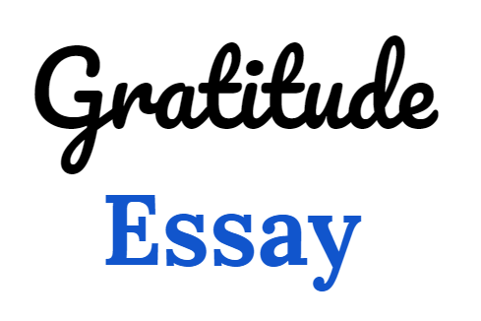

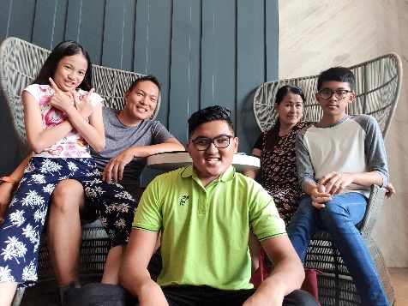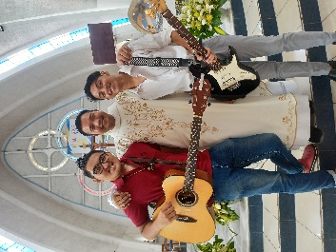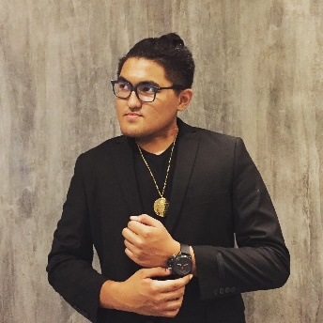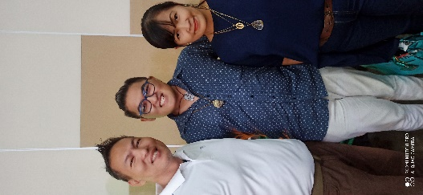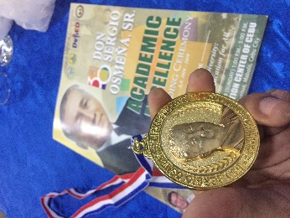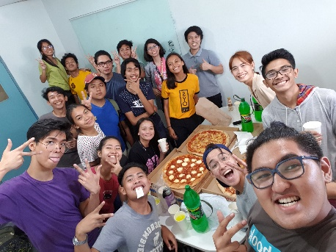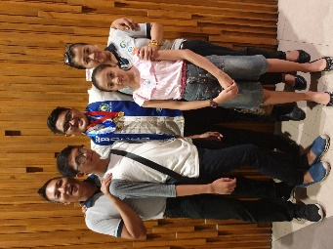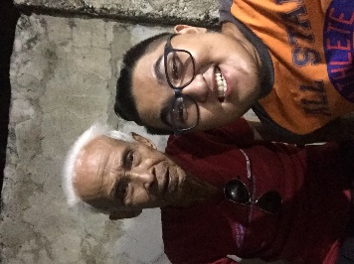

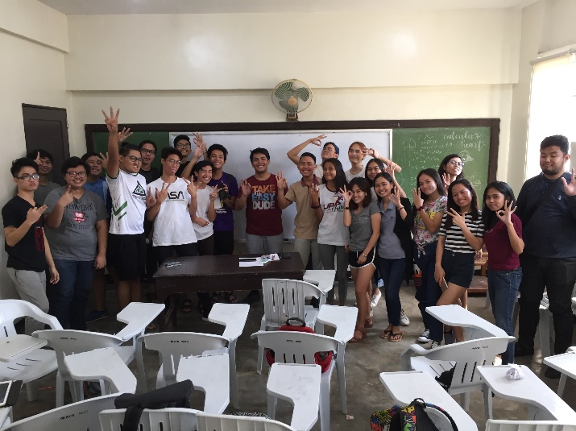

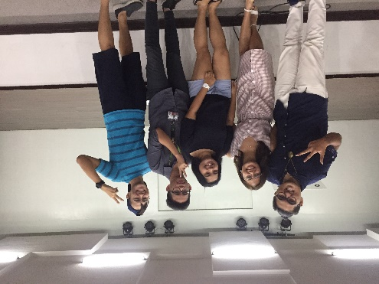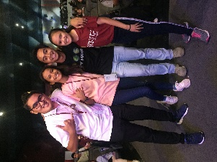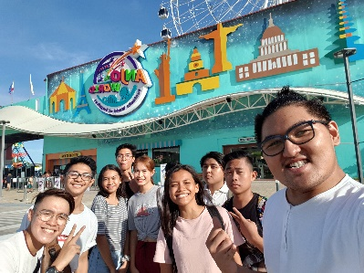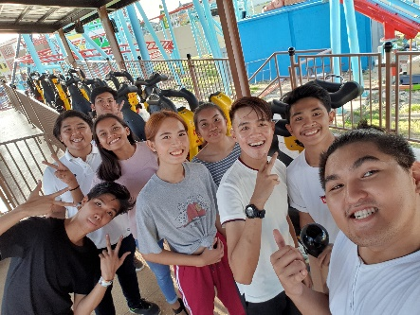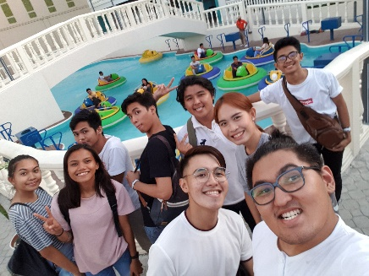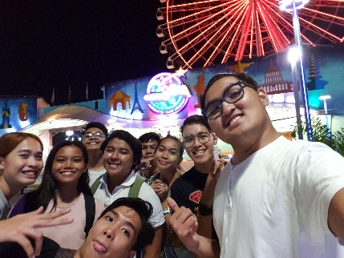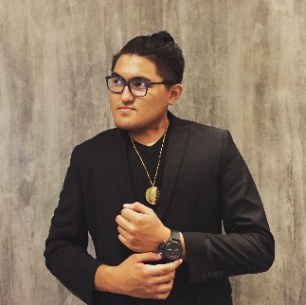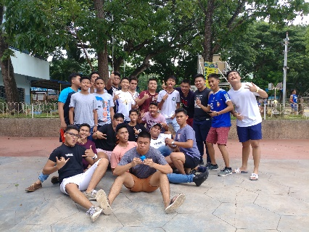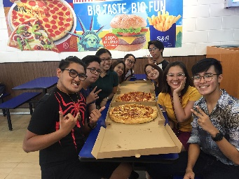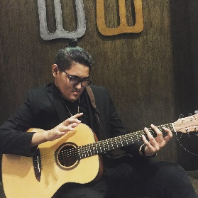

Date: **December 12, 2019, Thursday**

**TODAY, I AM GRATEFUL FOR:**

1. I was able to fix my things at home.
2. I was able to do the SAS requirement little by little.
3. I was able to rest.

**TOMORROW, I LOOK FORWARD TO:**

1. Go to school and get my LE.
2. Have a passing grade in my subjects.
3. Get inspired to go back to networking.
4. Buy products to sell.

Date: **December 13, 2019, Friday**

**TODAY, I AM GRATEFUL FOR:**

1. I was able to fix my stuff.
2. I was inspired to go back to networking.
3. I passed my Math LE.
4. I passed in the subject I thought I would fail.
5. I caught up with a good friend.
6. Miss Gen bought the product I shared with her in the past.
7. For being in a family that is selfless and would invest in relationships with other people.

**TOMORROW, I LOOK FORWARD TO:**

1. Finish my SAS journal.
2. Continue fixing my stuff.
3. Help around the house.

Date: **December 9, 2019, Monday**

**TODAY, I AM GRATEFUL FOR:**

1. I was able to get my 10k incentive.
2. I did my best in my final Math LE.
3. I got enough money to fix my old phone.

**TOMORROW, I LOOK FORWARD TO:**

1. Do good in the Stat quiz.
2. Get my phone.
3. Have the surprise with Sir Alvin.